**Session-20 Assignment**

**Name:-** Aryan Dilipbhai Langhanoja

**Enroll No:-** 92200133030

**AIM**: To understand various linear opamp applications like adder, subtractor, integrator and differentiator circuit.

**Objective:**

1. To understand various linear applications using opamp.
2. To understand working of various mathematical operations like adder, subtractor, integrator and differentiator.
3. To analyze the ideal and practical integrator and differentiator.

**Apparatus:**

1. DC power Supply
2. OPAMP uA741.
3. Resistor

**Task-1- Applications of op-amp**

1. Adder
2. Substractor
3. Integrator
4. Differentiator
5. Comperator
6. Buffer
7. Filter

**Task-2: Adder Circuit**

**Circuit diagram:**

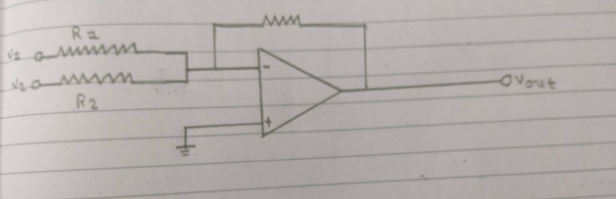

**Task-3: Subtracter Circuit**

**Circuit diagram:**

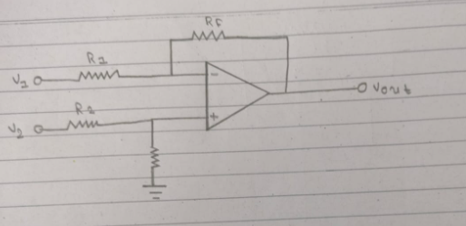

**Task-4: Integrator Circuit**

**Circuit diagram:**

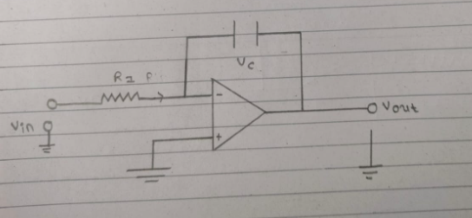

**Task-5: Frequency Response of Integrator Circuit**

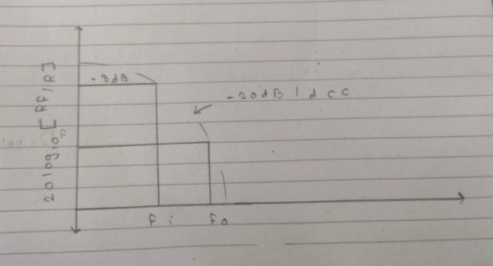

**Task-6: Differentiator Circuit**

**Circuit diagram:**

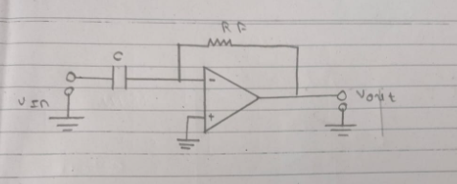

**Task-7: Frequency Responses of Differentiator Circuit**

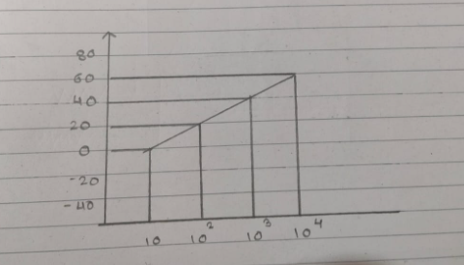

**Conclusion:**